# ADVENTURE PART 2

## Silver Rose

***Play: Chinese Festival Music***

You are starting your adventure in the Silver Vine Inn in the city of Silver Rose. Previously, you survived a zombie hoard attack in the town of Swallow’s Song and marched east to Swallow’s Bridge. At the bridge, you rescued the Silver Vine Inn Keeper, David, from a gang of bandits.

Ellana was incredibly wounded but was saved from death by Nosaj. Vehalla sustained some minor wounds, but it looks like your party will be alright.

**David** and his lovely wife **Mary Margaret** have given you free rooms and food, for your current stay in Silver Rose. They will also provide free ale, but not in excess.

The Silver Vine in is much nicer than the inn in Swallow’s song. The silvery stone floors are perfectly flat slabs that look recently polished. The wooden dark oak walls provide great contrast to the floors, and house beautiful iron sconces with dancing candle light inside them. Dark oak tables and chairs decorate the dining area, as well as a large, cobblestone hearth that heats and illuminates the room.

The rooms are equally as luxurious. The floors and walls are made up of the same dark oak from the main hall. A beautiful rug covers the vast majority of the floors and come in different colors depending on the room. The hand carved beds are blanketed with animal furs washed in rose water to give it a mild, but noticeable fresh scent. Unusually large windows with stone frames provide light and a cool breeze during the day. Although the windows lack glass, they can be closed with wooden shutters. Iron scones watch over the room and provide light when the sun goes down.

**What do you do?**

## In the inn:

There are quite a few people in the inn. Most look like wealthy families visiting the city on vacation.

Additionally, a woman sits solemnly in the corner. Her dress is perfectly tailored in Jaded with gold-left accents. Her curly chestnut hair is mostly pulled up, with perfect curls escaping down the sides of her face, framing it perfectly. Her milky, pointed ears announce that she is an elf. Her deep jade eyes stare off into the distance.

This is **Ayana**, a wood elf Female from Thels Dorei in the Temporal Forest. She recently lost her mate and is unwilling to talk. Males trying to charm her just makes her mad, as she is used to being hit on. However, another elf may be able to make her talk.

If Ellana tries to talk to her, she will open up about how her and her mate left Thels Dorei when the attacks started happening. They were used to giant spiders and other evil creatures in the forest, but nothing like this. It seemed there was an attack by the undead every night. When Ayana found out she was pregnant, they decided to need to leave. They nearly got to Demon’s Hearth when her lover was killed by a young (brass) dragon. She didn’t want to raise her first baby alone, so she’s heading back to the forest….

If Vehalla tries to talk to her, she yells “begone demon. You are not wanted!”

If Nosaj tries to talk to her, she refuses. If he tries to charm her, rolls 10+ charisma, she throws a drink in his face for being disrespectful. If he rolls low, he comes off awkward. She laughs politely at his attempt and tells him she lost her lover and doesn’t feel like chatting with anyone.

A priest of Talos is talking to Mary Margaret at the bar. He is bringing her some medicine for a bad cough she’s been experiencing.

If you listen, or if you go over, he’s talking about a crazy priest from The Talos Temple in the mountains that’s ranting and raving about a zombie apocalypse. As if Talos would ever allow that. The crazy priest is staying at the Silver Rose Talos Temple, which is thoroughly annoying the priest talking to you.

Everyone else in the inn just wants to talk about how amazing the food is in Silver Rose, how great the smiths are, etc. They all love Mary Margaret and David.

## In the street:

When you leave the inn, the smell of fresh bread immediately fills your senses. The bright and warm sunlight is complemented by the cool summer breeze dancing through the streets. Across from the inn, a woodworker is whittling a small wooden bear toy.

Next to the woodworker is a fairly large general store. They sell things like rations, tinderboxes, candles, bags, rope, and more.

Down the street, a baker is promoting his artesian breads, pies (including meat pies), cakes and deserts.

A specialty armor smith is polishing leather in his shop next to the inn. He sells normal armor (see phb) but can make special armor if desired (i.e. designs, colors, add gems, etc). He also sells non-standard armor that is not enchanted but can be enchanted (i.e. boots, cloaks). If you’re looking for something in particular, he can keep an ear to ground for it.

A tool kit store sits next to the bakery. They all types of tool kits and materials for tool kits.

Learning a tool kit Formula (not cannon, but easier to do)



A small courtyard is next to the armor smith where various venders typically set up their shop. Today, there is a man selling roasted corn, a woman selling wooden stones with hand carved runes, and a Rouge selling a lock picking kit for 5gp. She will teach you how to pick simple locks for an extra 1gp (lock picking set is useless without training).

### Kallista the Rouge

The rouge is incredibly beautiful. Her dark chocolate hair bounces around her shoulders and back naturally. Her eyes are a burning yellow and seem to glow. Looking at them feels like looking into the golden sun. Her pale skin looks smooth and fragile, like a porcelain doll. Her tight leather clothes show off her athletic physique. She wears thick silver rings on her fingers, no doubt, the result from a heist.

Her name is **Kallista**.

***Passive Perception Check DC 15: you notice some dirty children stealing fruit while the vendor is yelling at some birds.***

A bard is playing a lute and singing in the courtyard for money. She is very good.

### Ella the Bard

The bard is a beautiful human girl named **Ella**. Her skin is as black as coal, making her piercing sky-blue eyes hauntingly beautiful. Her white hair hangs in a long braid over her shoulder. She clearly has an accent, but its very uncommon. The bard looks almost like a human drow, but she clearly has no elf blood in her. Her beauty is intoxicating, however, even for elves. Her music draws in a crowd like a siren draws in sailors. She’s always willing to let you buy her stuff, but very unwilling to talk about herself.

Share info about herself: DC 20 Share info about the town/happenings: DC 15

Unusually she seems very interested in the Tiefling. Even when other people ask her questions, she seems to direct the answer at Vehalla.

If beats DC 20, she tells that she’s from another continent and came in through Arynsport. She couldn’t find a guide across the mountains, so she headed north. She was able to find a small pass, years ago, that went directly through the mountains somewhere. She entered through water reaper and came out somewhere woodsy, but very cold. That’s all she’ll say.

## Talos Temple

As you walk down the main street, you can see the spire of Talos temple to the north east of you. It is larger than the temples in Swallows Song, but not nearly as large as the other temples in Silver Rose.

The temple is made of large, gray stone bricks. Despite it’s age, the bricks are clean. Inside the temple, the marble floor is dotted with stone columns and leads to a small platform that is the home to a stone carving of Talos. On the steps of the platform, a man is shivering and crying.

When you arrive, the church officiant is muttering something about a ‘god forsaken’ priest as he passes you.

The priest is **Taoba**, and Vehalla recognizes him as the priest she saw at the temple in Swallows Song. She recalls the conversation where he was insisting that he could make it up the mountain despite the storm

The priest, Taoba, tells you that he had barely started his ascent up the mountains when he heard the undead. He was able to hide from them by taking a less known path up the mountains. He discusses how the temple had been raided as he watched from afar. Once the undead men had left, he went inside. Everyone was dead, and a special talisman used for opening portals to ShadowFell was missing.

He asks if you believe him.

Upon hearing that you believe him, he seems relieved.

“Thank you for listening. It really helps to know I’m not crazy. This temple is my home now, and I haven’t been the best guest since I arrived last night. OH!” he seems to remember something suddenly. “A Talos relic has been stolen from the temple. It’s a strange thing to steal, since it’s not made out of precious metals and is useless to about everyone but a Talos priest. If you hear or see anything about it, I’m sure Talos would be very grateful for anyone who retrieves it. If you gain enough favor, perhaps Talos will allow you to cross the mountains.”

Outside the temple, you can hear a man screaming. If you walk over, a giant of a man is shouting at some fleeing children. The man is tall with dark skin, hair and eyes. His thick arms are covered in burn marks and scars so old he’s forgotten they’re there. The man is a blacksmith, and returns to his anvil when the children are out of earshot.

If you talk to him. **Rejak** tells you that children have been attempting to steal his stuff. The children stink of sewer and are plaguing the town. More and more orphan children have been showing up in town, rambling about dead men attacking their village. He mutters something about children having overactive imaginations and if they’d just respect their fathers, their fathers wouldn’t have to be compared to monsters. Anyway, the children did manage to get one of his forge hammers. If someone got it back for him, he could trade some stuff that is useful to him but might be useful to travelers. Rejak sells simple weapons and martial weapons, but can make custom weapons too. He is not a magic user and cannot enchant anything. If you’re looking for something in particular, he can keep an ear to ground for it.

A stinky small satchel full of blinding powder (3 uses), a Philter of Love potion (once consumed, the consumer becomes charmed by first creature it sees. If target is a creature and gender that it is normally attacked to, they believe this is their true love. Lasts 1 hour), and half used bottle of Potion of Hill Giant Strength (+ 21 strength for 1 hour, but since half drank, 30 min).

**Queue Optional Adventure**

A homeless woman somewhere is yelling at pedestrians that the end is coming. The dead hath risen from their slumbers and safety of the world is at stake! Passersbys quickly shoulder her away.

When asked, the old woman cant remember her name. The rags she wears could be older than anyone in the group from the way they look and smell. Her odor is impossible to ignore and reeks of urine, feces, rancid meat and dead fish, among other things. Her ratty, wiry gray and white hair did nothing to hide her searing honey colored eyes.

She tells you that Jergal worshippers have been raising the undead to kill all man kind.

“The dead like to play in the forest, but they are not from the forest. But the forest is where they play.” She sings. She stops dead when she notices the tiefling, like she had a moment of clarity.

“Death, death! Kill her! Kill her! She brings death! You and your master won’t get me! Kill her!” She takes off running.

## Back in the Inn:

Ayana has left and the dining area is empty (either its late or everyone is sightseeing) except Mary Margaret. She runs up to you and says that Ayana had lost the wooden ring her lover had given her. She had to take it off since it didn’t fit currently due to pregnancy. Ayana was deeply upset about the loss of the ring, but said that the baby could come any day now and she needed to be back in Thels Dorei before that happened. Mary Margaret asks if you plan on heading to Thels Dorei, and if so, if you could deliver the ring.

If you decide to go, Mary Margaret recommends stopping in Serenity Garden. It’s the last town before you get to the forest. She warns you that travelers have gone missing along the path to the Gardens so be careful!

The forest is quite far away and will take about 3 days to get there.

## To Serenity Garden

**Play RELAXING Tropical Music….**

The northern gate out of Silver Rose is where your new journey begins. The beaten path is lined with the brightest green grass you’ve ever seen and stands over a foot tall. The summer sun bathes the hills in golden light and the cool breeze creates hypnotizing waves with the tall grass.

**Mingle Amongst yourselves as you walk**

Slowly, you notice the tall grass becoming shorter and mixing with beautiful wild flowers of every color imaginable. Eventually, it seems the flowers have completely taken over. Millions of flowers dance in the sunlight around your path to Serenity Garden. You see a sign, struggling to survive amongst the tall flowers, that indicates you’re about half way to the Garden Village.

**Do you want to do anything?**

As you walk, you notice a rose patch hiding in the flowers/surrounding the path. The roses are all different colors such as red, blue, purple, white, and pink. These roses smell extra sweet. As you look around, you notice the most enormous roses you’ve ever seen waiting to bloom. The rose bud itself was the size of a man’s head, the thorns on the vine as thick as fingers, the stem as thick as limbs. Something shiny catches your eye. It looks like liquid silver.

**What do you want to do?**

**Roll a dice for who is going to get wrapped.**

A strong breeze blows through the rose bush, one of the large rosebuds rotates. You feel like its staring at you. A single drop of the silvery liquid drips from the rose’s petals.

Suddenly, a thorny vine wraps whips out from behind you and wraps around _____’s leg pulling them from their feet.

**Play d&d Battle Music**

As you turn, you see a large rose, standing as a humanoid, it’s stems forming a torso with arms and legs. Its thorny arm continues to pull ______ towards them as their rose starts to bloom, revealing a foul smelling, toothless hole. A drop of the liquid falls from the rose’s mouth onto ______’s shin and burns a tiny hole in their clothing and skin.

**What do you do?**

(get them down to low HP).

Your weapons don’t seem to bother the rose very much. Hearing the battle, the other large roses begin to move. You can see their slow-moving vines crawling towards you as the foul stench of their acidic fluid smells the air. Perhaps some have already been ensnared.

Suddenly, a tiny bubble of light comes shooting through the rose garden, A fine powder trailing the speeding light. As the powder begins to settle, the carnivorous rosebushes let out an unsettling wheezing sound and quickly release ______. The remaining rosebushes either flee, or camouflage back into their homes.

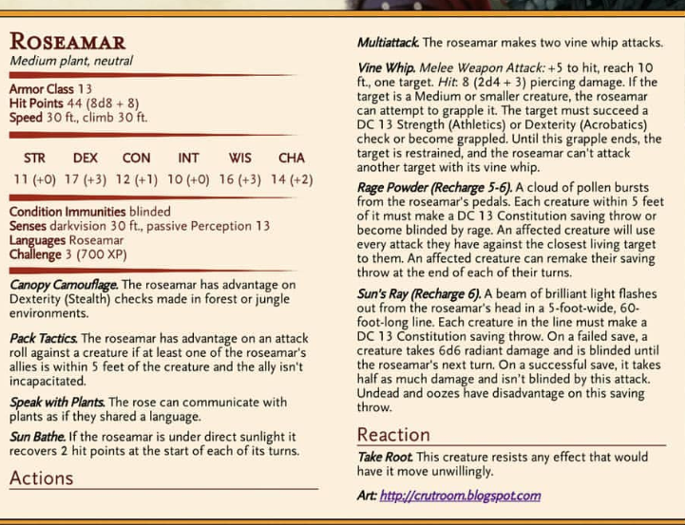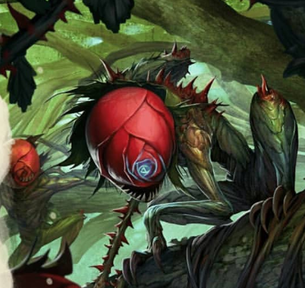

The speeding light zooms towards you and lands gracefully on a normal sized pink rose.

**Play Cheerful Happy Music**

As the light fades, a tiny girl with green butterfly wings stands in front of you. She couldn’t be more than 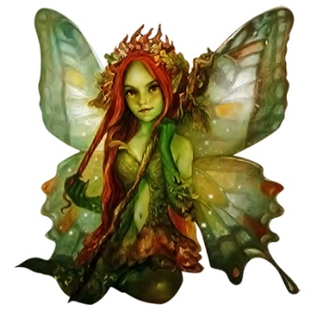6” tall! Her long red hair cascades down her pale green, freckled face and is decorated with small twigs and leaves. She giggles and smiles at you, her amber brown eyes playfully awaiting a “thank you”.

***Things she’ll tell you:***

She is a bright pixie (they like the light)

Her name is **Basil**

Those things were Roseamar and they drip silvery, corrosive acid to attract and eat pray. The Pixies that live in the Flowers have a special pixie dust that the Roseamars don’t like.

If you’re kind to her, she tells you to come back and visit her at the Pixie garden, if you can find it.

“But you’re too big! So you’ll have to be small first!” she gives you **party + 1 uses of Pixie powder** that will make you pixie size. The bag she hands you is no bigger than an almond. Basil takes out another pouch and flutters up to your hand and throws some powder onto the pouch. The pouch promptly enlarges to the size of coin pouch. She explains how much to use, and that it’ll last 30 minutes per use, unless you’re in a Pixie Village. Then It’ll last until you leave.

She playfully urges you to rush to the ‘Human Garden Village’ (SerenityGarden) for healing and resting. The rest of the road should be safe if you stay on the path.

And with a giggle and a hope, her tiny wings flutter and carry her away.

Your wounds hurt, but the Roseamars start moving again, slowly, as Basil departed.

**What do you do?**

**Play Peaceful Music, Relaxing Music….**

As promised, the rest of the walk is peaceful. Despite the same summer sun, brisk breeze, and waves of flowers, the landscape just doesn’t have the same appeal anymore.

The sun begins setting, soothing the land into sleep with its comforting redish-orange glow. Up ahead, you can see the torches of Serenity Garden beckon you towards them.

The garden village is beautiful. The purple and white flowers decorating the pathways await their beloved moonlight. At the end of the path, surrounded by small wooden homes is a pond. The pond is captivating and reflects the glow of the setting sun. A small dock protrudes into the lake from the path.

The houses are made of wood with flowering vines hugging the walls. The mossy rooftops are the home to tiny white flowers that are preparing for bed as the warmth of daylight is nearly gone.

The village is void of people, but the smell of freshly cooked dinners lingers outside their doorways.

You see a sign on a small wooden house that provides shelter for adventures. The room is musky but provides two bunk beds with freshly cleaned sheets for travelers to say in. A small fireplace is the only decoration in the room and has a small cast iron pot hanging above it for soups.

**What do you do?**

Serenity Garden is just as beautiful during the day. Only about three to four dozen humans live here. You can see women and children praying at the pond, tending to their personal gardens, and carrying large wooden buckets to a well for water. Men are chopping lumber or repairing houses.

They pay your group no mind; they are used to adventures but want no part in anything outside the Garden.

They don’t really say much. They’ll tell you that they don’t go really leave the town. They’ve heard of the Roseamars but no one ever leaves the village that far so they don’t know anything about it. They also know that there is at least one pixie village in the area, but again, they only leave the town to hunt rabbits and birds.

They have almost no information about anything. Except that it’s about another 6 or so miles till you reach the forest.

IF you mention going to the forest. They ask if you’ve heard about the mansion. They don’t provide any information; they just hurry away and go in doors.

## To the Mansion:

The first part of your walk is uneventful. The flower patches turn back into tall grass fields. The tall grass tapers off into short grass. Your landscape slowly starts to incorporate skinny oak trees until you’re confronted with a wall of forest. The forest, the Temporal Forest, is incredibly dense and dark. The canopy of leaves stands 50 feet overhead.

**What do you do?**

The tree roots protrude from the earth and await distracted feet.

Dex(Acro) check. DC 10. If fail, trip and cut your arm (potential fungus/growth)

MARK WHO FAILED IF ANYONE: ______________________

Unfamiliar noises echo through the darkness…unfamiliar to all but Ellana who grew up in the forrest.

The path seems to disappear ahead of you as a chilling mist fills the air around you. Even with half elven vision, you are unable to see more than 2 feet in front of you.

**What do you do?**

The mist doesn’t seem to clear, but your mind begins to become hazy. You are fighting the urge to fall asleep.

**What do you do?**

As you walk out of the fog/when you wake up, the fog has cleared in front of you. Despite it still being morning, it is as black as night. A beaten path glowing with lanterns illuminates a graveyard in front of you.

About 5 dozen tomb stones stand erect in the cemetery. Many are crumbling away, while others look brand new. At the end of the path, behind the cemetery, stands an enormous mansion. It must be 4 stories tall, at minimum. The walls are some dark wood, nearly black, with windows so dirty or cracked that it’d be impossible to see inside.

If they look at the gravestones OR roll Passive Perception DC 10

As you (pass by/examine) the gravestones, a sudden chill runs down your spine. The gravestone has your name on.

**What do you do?**

You notice with chilling dismay that each and every gravestone has your name on it.

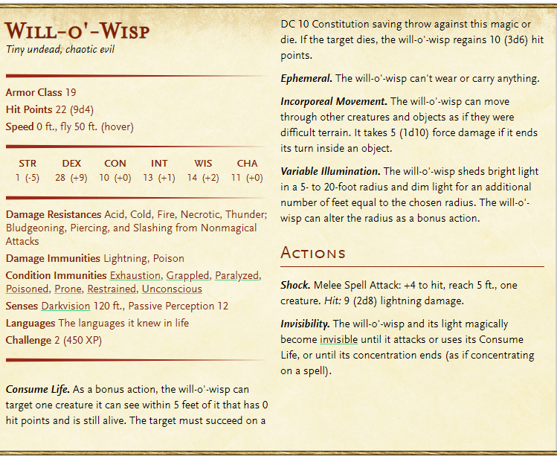Tiny lights glow in the dark. Ahead of you. They seem to be slowly flying around on their own. They notice you, but don’t seem aggressive.

DC Arcana to identify as Will-o’-Wisp.

They do not fight but will fight back if you attack them.

**What do you do?**

A deep rumble fills the air. The gargoyle knocker on the wooden door to the mansion seems to have knocked itself. The forest falls completely silent

**Kill Music**

The giant door creeks open, daring you to enter.

**What do you do?**

No matter what direction you turn, the mansion is always in front of you, its open door seeming to become closer and closer.

### Mansion Pt 1

**Play the Mansion Opening**

#### Main Hall

The mansion’s floors are solid wood that are slowly decaying, yet the wood doesn’t seem to creek when stepped on. The walls are divided by wooden chair rail. The bottom portion is solid oak with oak square frames every few feet. The top portion is mostly red with a white trellis pattern. The white, however, has faded to a yellowish-gray with age.

As you enter the main hall, you notice two towering suits of armor standing sentry against opposing walls. A huge red rug decorates the floor in front of you, illuminated by a wrought iron chandelier hanging overhead. About 20 feet in either direction exists two dark wooden doors. At the back of the room you notice a stair case, blocked off by floor-to-celling gates. Portraits of rich men and women hang tattered on the walls. In some, their dead eyes seem to follow you no matter where you go. Other paintings are completely blank, as if the subject had gotten up and left.

As you look back at the front door, you’re unsurprised to see the door has completely vanished.

**What do you do?**

**\***If they try a door or examine the suit of armor*

The door to your right is locked and unmoving. You notice a keyhole, however.

The door to your left is locked and unmoving. You notice a keyhole, however.

Suddenly, the suit of armor turns to look at you! It’s animated joints squeak as it takes a step forward, garnishing it’s broadsword. It swings at _____, painfully missing.

**What do you do?**

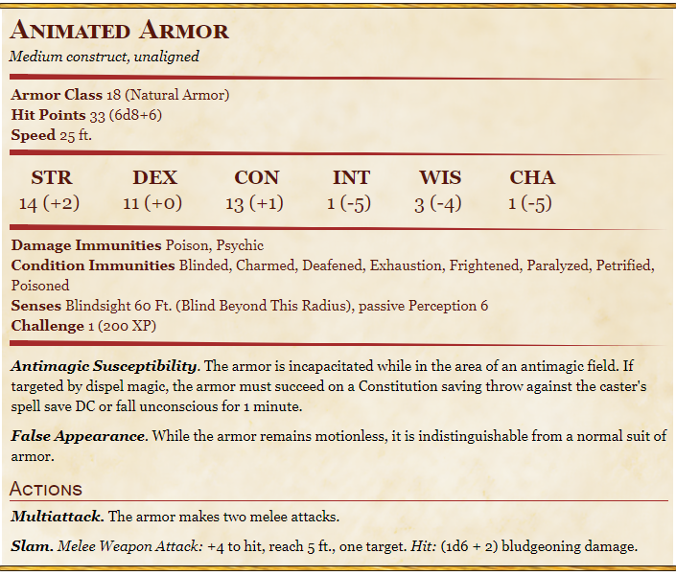

The armor falls to the floor, pieces of metal scattering everywhere. Magically, the suit begins to pull itself back together to an upright position and returns to its post. It doesn’t appear as if it’ll bother you again.

Where it fell, you see a small, iron key.

The door to your right is locked and unmoving. You notice a keyhole, however.

(left door) the hinges creak as you open the door.

#### Left Hallway

The left hallway is completely barren. There are two doors, one about 30 feet in front of you, the other about 15ft ahead on the righthand side.

**What do you do?**

#### Cabinet room

There are two old cabinets directly in front of you. That is all that is in the room.

**What do you do?**

One cabinet is locked.

It contains A Lich skull and an large (owl) egg. Despite being locked in a cabinet, it seems to still be alive.

The other cabinet is not locked. It contains (number of players) Healing potions. The potions do 2d4 + 2 healing each. As well as a pair of sending stones (can send a ‘text’ anywhere (diff plain has 5% chance of failure) of 25 words or less to the other stone).

**What do you do?**

#### Shadow Room

You enter the room and the lights immediately flicker out, but re-light themselves. When you look around, you notice you are completely alone. A thundering click echoes from the two doors in the room: the one you just entered from, and another to your righthand side. (the doors are locked).

In the room, you see four pieces of furniture, all draped with decaying white cloth. On the northern wall, you see a love seat. On the western wall, a tall and slender item. On the southern wall, you notice two arm chairs, one in each corner.

**What do you all do?**

The tall item is a full length mirror in a golden frame. There’s something wrong with your reflection though. It looks like you, but something is just a little off…You are hypnotized by it and can’t seem to look away.

Wait till everyone is looking in the mirror.

An eerie cold fills the room and you are compelled to turn around. Your shadow seems to get longer and longer as the lights dance around the room.

**Play Shadow Battle**

It grows so long that it begins running up the wall on the opposite side of the room. Your heart drops. Your shadow on the wall takes a step towards you.

**What do you do?**

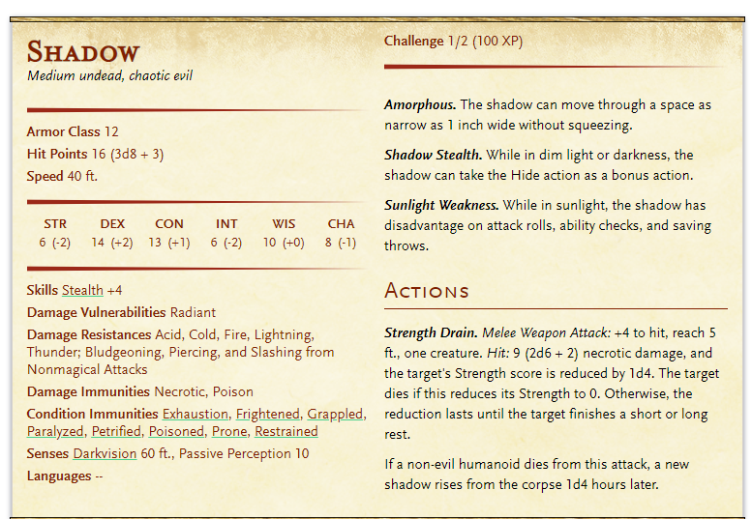

The shadow flees and a key is dropped on the floor. It seems somewhat transparent, like the ghost of a key…It cannot be picked up.

Once everyone has beaten their shadow…

The key seems to fully materialize, and you hear a loud click as both doors unlock. The torch light flickers out into complete blackness, and re-lights itself again. Your companions are standing next to you surrounding the key.

If you die, the shadow disappears. The key doesn’t fully materialize but the rest of the stuff happens. Upon re-entry, the whole group fights your shadow.

**What do you do?**

Key **Opens Study Entrance**

#### Armored Hallway

The next room creaks open and displays a long hallway. The west wall displays suits of armor every 5 feet. At the other end of the hall, you see a door way. Nearing the end of the hall on the east wall, is another door.

The door to your right is locked and does not seem to be a simple lock.

#### Weapons Room

The rooms look like the remains of a weapons room, although the silhouettes of missing weapons still linger on the walls, several weapons still lay around the room. To your right, a smaller hallway leads to another door. On one side of the door, there is a bookcase. There is a nail on the side of the bookcase that has a key hanging from it (**Opens Kitchen)**. On the other, an end table. There is a pretty golden bear statue on a golden disk. It looks like it might be expensive.

A mace lies on the table. (Inspection shows Magma Mace. Head is a ball of ever burning magma. Deals fire damage instead of bludgeoning)

Also on the table, you see a dagger (inspection shows Poisoned Dagger. Retains poison it is covered in until covered with different poison) (it is covered in Drow Poison. DC 13 Const Save or be poisoned for 1 hour. Roll <8 (13 – 5) it passes out. If unconscious, wakes up if more damage is taken or if someone tries to wake them)

You see a quiver of arrows leaning up against the wall (inspection shows 20 Frost Arrows, normal damage + 1d4 cold damage. DC 12 Const Save from victim. If fail, movement is ½ till next turn).

Next to the quiver, you see a bow made of white wood (inspection shows Bow of Sun Rays. 2 charges use a charge to make an arrow glow with light for 10 min. DC 14 Const save for victim if hits something. If fail, blinded. Regains all charges in the sunlight for 1 hour).

A large Warhammer sits on the wall (inspection shows Berserk Hammer, Smash on ground instead of hitting enemy. All enemies within 10ft must DC 8 + wielders str mod + prof bonus. If fail, fall prone (unless large creature. Then always succeeds)).

*if tries to take more than 1, the other weapons turn ghost like and slip through your fingers*. Once all 3 have taken weapons, the other weapons fade from existence.

#### Dining Room

Through the unlocked door, you find a dinning room. You can tell this room used to be beautiful. A long table fills the center of the room and seats 7, 5 on both sides plus one at the head of each side of the table. A red table cloth covers the table. Other than a dead bug, nothing else is on the table. To the right of the table you see a long serving cabinet. Old bottles of wine still linger, along with plates. It also seems like there are some jugs of water.

On inspection, find 3 lesser potions of healing.

There are 3 other doors in the room. One is to your right upon immediate entry into the room. Another is to your left, halfway through the room. The final door is on the other side of the room.

**What do you do?**

All doors are locked. The door in the center of the room is large and beautiful, with crimson and gold paint. The keyhole is gold as well.

#### Armored Hallway Reprise

**Play Shadow Battle**

Back in the Weapons room, you hear a suit of armor walking around in the next room.

Upon defeat, the suit of armor peacefully returns to its post.   
**Play Mansion Music**

**What do you do?**

#### Kitchen (if got key from Weapons Room)

**If someone tripped their wound is starting to get itchy**

The key you got from the weapons room successfully unlocks the door. In the small room, you find a kitchen. The kitchen is disgusting. The stone walls are covered in mold and blood. To your right you see cabinets that are stained with animal blood and mold. A cauldron-like sink divides the cabinets. At the end of the room, still to your right, is a metal chest that you recognize as an icebox for the richest of the rich.

To your left, you see a dumbwaiter. Next to it are two French doors. Beyond the pantry there is another door.

At the end of the room, you see another door. Unlike the other doors. It looks like this one slides into the wall…

The sink and is filled with stagnate water that reeks of disease. Something moves in the water.

To the touch it doesn’t feel cold. Inside, you find rancid body parts from humans an animals. Some parts are limbs, other are intestines. The stench fills the room makes you feel sick. Const check DC 15. If fail, throw up.

Upon inspection, it looks like the dumbwaiter is still functional. No one is small enough to get inside it though….

The two French doors lead to a walk in pantry. Not a lot is in here except moldy bread and rotten fruit.

The door is unlocked. Upon opening it, it opens up into the dining room. By opening it, it is now unlocked from both sides.

The sliding door enters into the main hall, near the stairwell. By opening it from this end, you have unlocked it on the other side.

#### Servants Quarters (optional)

The dumbwaiter raises you up to large room above the armor room. 3 sets of bunk beds lay awkwardly in the circular tower. There is a door to your right. There is shelving on the wall that hold a few potion bottles.

**What do you do?**

The potion bottles look as if they once held all sorts of potions. It appears as if there are 2 healing potions left on the shelf, along with a recipe book for healing potions.

|  |  |  |  |  |  |
| --- | --- | --- | --- | --- | --- |
| Name | Rarity | HP Regained | Price | Days to Create | Level Req |
| Lesser Healing | Common | 2d4 + 2 | 25 gp (50gp) | 1 day | 3rd |
| Greater Healing | Uncommon | 4d4+4 | 100 gp | 5 days | 3rd |
| Superior healing | Rare | 8d4 + 8 | 1,000 gp | 15 days | 6th |
| Supreme Healing | Very Rare | 10d4 + 20 | 10,000 gp | 20 days | 11th |

Someone with an herbalism kit and proficiency may be able to craft potions for cheaper.

The items are too heavy for you to lift.

The door is slightly ajar, and you are able to sneak through. The hall is very plain. At the end on your righthand side there is a door that is latched. A crowbar leans on the wall next to the door.

**What do you do?**

You are not strong enough to open the heavy door, but you are able to undo the latch.

**What do you do?**

#### Main Hallway Reprise

Back in the main hallway, the key the shadow dropped allows you to open the right door. It leads to a long hallway decorated with more creepy portraits and a long rug. At the end of the hallway is another door.

**What do you do?**

Unlike the portraits in the main hallway, these faces aren’t even trying to not to watch you. As you move down the hallway, their beady, hateful eyes clearly follow your every move.

The door at the end of the hallways is unlocked.

#### The Study

This room is obviously a study. Bookcases line the walls and contain a thousand books and scrolls from floor to ceiling. In the center of the room, there is a regal looking desk and chair upon another red rug.

**What do you do?**

On the table you see a notebook. Most of it just looks like the diary of a crazy person, ranting about mists and a Red Eyed man who stands outside of Lucy’s Window at night. On the last page, it mentions something about a hallow sounding spot under the rug in the main room that was never there before. A potion of lesser healing sits on the desk as well.

Make up shit for each bookcase (like it’s all the same author, the books are all about Vampires, there seems to be no pattern, it looks like someone attempted to alphabetize it, but gave up)

There are two golden statues on a stone rectangle: a Wolf and a Lion. Between them, there is an outline of missing piece. **(place bear statue if found in Weapons Room)**.

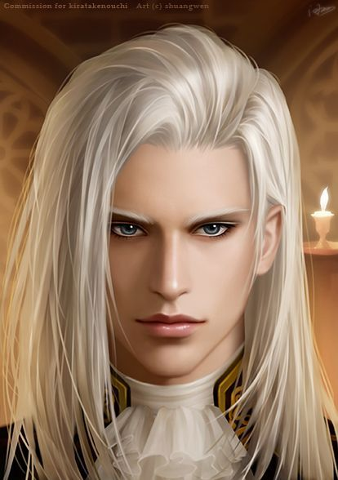Upon completion, the bookcase swings backwards and reveals another room!

#### Jade/The Fireplace Room

This is a large hall, with an enormous fireplace on the righthand side. A giant fire blazes in it and fills the room. In front of it, a love seat and two sitting chairs are arranged around an oval rug. You see a door at the end of the room on the left-hand side. On the right, you notice a circular tower that is gated off. Next to it, a thin table with an open book on it.

Above the fireplace is a portrait of a hauntingly beautiful man. His silvery white hair fell in whisps around his flawless face. Despite it being a portrait, it was hard to tell if his eyes were blue…or red.

A sudden clap breaks the silence.

A young girl rises from the chair that was facing away from you.

“I’m impressed you made it this far,” she says condescendingly. “I bet my master that you wouldn’t make it past the shadows. But here you are. You must be proud of yourself.”

The human girl must only be 25 years old. Her auburn brown hair was pulled into a high pony tail with curly locks framing her face. Her green eyes were like small emeralds glowing in the fire light. A Rapier was loosely clutched in her left hand. She waits to see if you have anything to say.

Name: Jade (given to her by her master)

Class: Rogue

HP: 48HP (level 8)

Skills: Acrobatics, Sleight of Hand, Stealth, Deception

Weapon: Rapier (1d8 + Dex)

Abilities:

Str: 11 (+0) Dex: 16 (+3) Con: 11 (+0) Int: 14 (+2) Wis: 11 (+0) Cha: 15 (+2)

AC: 15

**Play DnD Battle Music**

Jade is starting to bleed out as she clutches her ______. She gracefully rolls away from the group towards the back of the room, and lays her hand on the door.

“My master is going to kill you,” she snarls before darting through the door, giving you little time to respond.

Even if you pursue, she is no where to be seen. This room leads to the dining room and now unlocks that door from the other side.

**Play Mansion Music**

If you inspect the book on the table you will see a riddle (put out fire and Main Hall gate opens):

Next to the table, there is a round, metal hole in the wall. It appears as if something will fit into it.

A spirited jig I dance bright,

Banishing all but darkest night.

Give me food and I will amplify;

Give me water and I will die.

And if you bring me to my end,

An unholy accent you will begin.

You clearly hear a gate rising, but it is not the one in this room.

**What do you do?**

### Mansion Pt 2

#### Main Hall Reprise 2

Trap Door: The trapdoor is completely flush with the floor and is stuck. It seems like something could pry it open…

The gates surrounding the stairs at the back of Main hall have been removed.

**What do you do?**

There is a lot you can do at the top of the stairs. On the wall in front of you, there is a door. To your right, there are two doors, separated by an indented resting area. Behind the stair case, a glass door leads to what appears to be a balcony. West of the balcony, there are 4 doors: 2 on the south wall and two on the east wall.

#### Servants Quarters Hallway

The door seems to be locked from the other side OR the door opens easily.

The plain hallway leads to another door that is slightly ajar.

Collect the 2 potions, the notebook, and the crowbar. **Crowbar opens trapdoor**

#### King Bedroom

The door to the right leads to a bedroom. To your left, you see a vanity with a large mirror. In the NE corner of the room, there is a king sized bed with nightstands on either size. The covers are complexly black, expect for the dust that has collected on it. On the floor, a white bear skin rug adds accent to the room. The room has a thick lock on the heavy door. It should be safe to sleep in.

**Twist:** As you are sleeping, you hear a voice coming from the southern wall. As well as a very dim, pale light leaking through the paneling on the wall.

Upon inspection, you find that it is a secret door.

**What do you do?**

Upon opening the door, you notice a room full of mirrors. Full length standalone mirrors, circular wall mirrors, hand mirrors and more litter the walls and floors.

The largest mirror is in the back of the room. It is floor to ceiling and is bolted to the wall. Your reflection is eerie, just like in the room where you fought your shadow. You can’t help but feel like *it’s* watching you.

Suddenly, you are pulled from your feet.

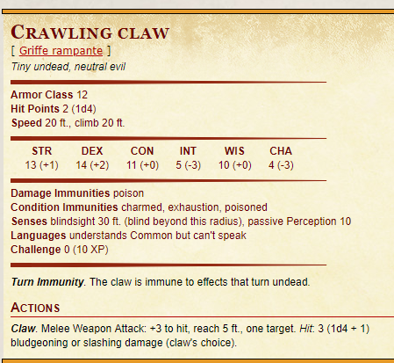**Play Epic Dark Music**

As you fall on your back, you see hands – your hands – coming out of the mirrors and clawing at you. They are holding you down. To your dismay, you see your reflection, the one that is all wrong, step from the mirror towards you. It smiles at you as you struggle to escape. It steps over you and leaves the room, shutting the door behind you.

There are at least a dozen hands holding you down.

Even if you get all of them off, you trip and pass out if everyone is asleep.

Basically, let everyone fully heal.

DC 18 Perception each turn to see if you notice something is wrong with _____. DC 10 and under doesn’t believe it at all. If one notices, DC 13 to other person next turn to see if they notice.

Nat 16 or higher DC check to break down door.

#### Guest Room

The second door leads to a guest room. In the room, there are two beds on opposite walls. One blanket is a soft pink color, while the other a pale yellow. The room is unusually bright. Next to the beds are two-night stands. In the corner, there is a potted plant, but it is dead. This room feels safe to rest in.

Nothing eventful happens.

If the person in the king room is in the mirror room, then the other two are in a magic induced deep sleep.

#### Nursery

This room is a nursery. In it, you find a rocking horse, a child sized bed, an oversized bounce ball along with some blocks and toys, and a large soft pink rug. The walls look like they were once pink as well. There is also a dresser with a picture of pretty little girl, about 8 or 9 years old, in a blue dress.

Upon inspection, you find a creepy porcelain doll in the crib. The doll’s face is cracked and is wearing a gothic style black dress and bonnet.

Upon inspection a key is hanging from the rocking horse’s neck. **Unlocks the upstairs study**

#### Bathroom

There is nothing in this room except a bloodstained floor, and an old bathtub that hasn’t been cleaned in a long time.

#### Broom Closet

The door is locked but you notice a keyhole (enter the study first).

#### The Study

The study is less extensive than the one downstairs. It only has two bookshelves in the back of the room, with a desk in front of them. An arm chair is in the corner.

Upon inspection, you notice all the books are about Vampires, the undead, and necromancers.

Upon inspection, a journal is on the desk.

Upon inspection, the journal is tear and blood soaked. Read a few pages.

The ghouls have been louder than usual. Lucy asked what the difference between Ghouls and Zombies are. Until now, I never thought to ask.

It seems ghouls are flesh-eating and can problem solve, which is problematic. They enjoy both fresh and rotting meat, and will attack when hungry, which is all the time. If killed by a Ghoul, it is possible to become one…

Zombies are mindless. Typically, they only consume living flesh, but only when particularly hungry. Zombies will attack if someone or something is in the way of the Zombie achieving its purpose. Zombies are typically created by necromancers to guard something or carry out a pre-determined task.

Either way…best to avoid them.

The scribblings continue, becoming less and less legible. On the last page, you read something haunting.

Lucy is gone. I told her not to wonder into the cemetery, but she wouldn’t listen. I didn’t have the time to bury her, so I brought her back into the mansion. I put her away in a room, but I can’t stand to leave my sweet baby girl alone in the dark…. The door locks from the outside, so even if she changes, she cannot get out…. This will be my last entry.

The rest of the message is smudged with tear stains and is unreadable.

You hear a small clatter in the hallway, as if something small and metal was dropped on the floor.

Investigation Check DC 5 to find the key that dropped in front of the study door.

#### Doppleganger

Two things can cause the DG battle. 1) if the captive person breaksdown the mirror room door (Nat 16 DC) or if one person notices the DG (DC 18 Perception) and the other person gets (DC 13 Perception on same or following turns).

The DG attacks.

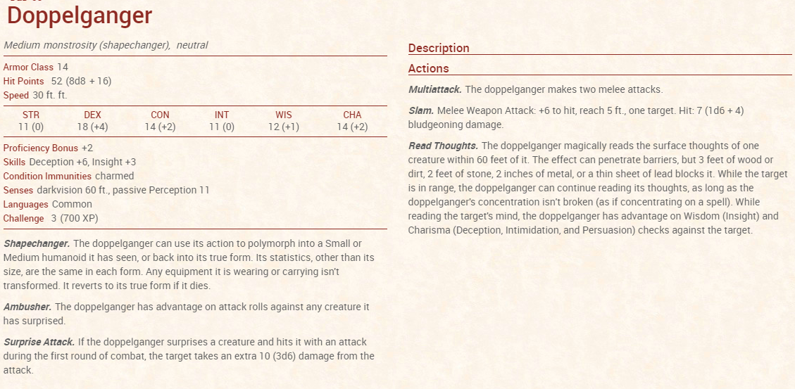

The DG screams in pain as you cut it down. Its stolen flesh begins to melt off it’s bones as it tries to flee. Eventually, there is nothing left of the DG, except a pile of bones, boiling blood, and melted flesh. The stench of burning beat fills the air.

*if person couldn’t get out of room* The door is magically unstuck and you can open it as easily as when you entered.

#### Lucy and the Closet

The key that dropped unlocks the final room upstairs. It appears to be a storage closet, but smells rancid. Near the door, you see a rotten corpse, nearly fully decayed. It must have been there for some time.

**What do you do?**

On the body you find a hand crank that will fit into a small metal hole.

A low growl echos from the back of the room…. Suddenly a child sized creature comes charging at you knocking you to your back. The creature is a small girl in a pretty blue dress. Some of her flesh is missing and her dirty dress has blood stains on the arms and sides. She charges again.

**What do you do?**

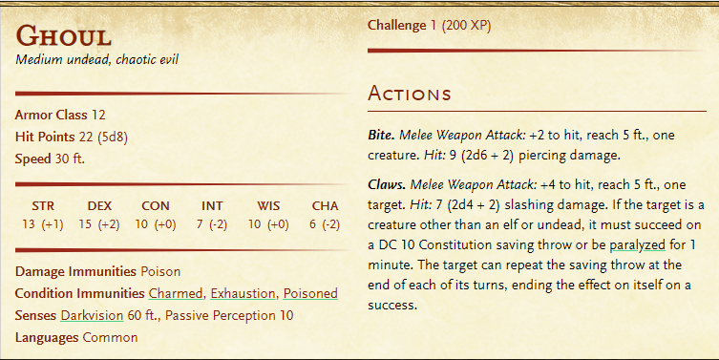

#### Fireplace Room Reprise

The crank fits perfectly into the small hole. As you crack it, the gates rotate to the other side of the room, allowing you access to the descending stairwell.

### Mansion Pt 3

The temperature between the main mansion and the underground crypts drops exponentially. The smell of mold and decay fills the room, hall, or whatever you’re in. There are no lights down here. All of you have dark vision, so you can make out shades of gray in the darkness.

As your eyes adjust, you can see that you stand at the mouth of a hallway. Even with your dark vision, you cannot see the end of the hall. It appears as if there are cell bars on your right hand side, down the hallway

#### Spectator

**What do you do?**

The first cell is empty, except for some old bones of human remains

The second cell (unlocked) has a chest in it. It contains 1 lyre, 11 lapiz lazuli (10 gp each), and 100 gp.

The third cell is empty.

At the end of the hallway, you see what a large, cavernous room could be. As you get closer you realize it’s about 50ft long in both directions.

As you walk into the room, a gate crashes down behind you, blocking you into the room.

A nasty wheezing sound echoes through the room. You can mildly make out a strange circular shape in the middle of the room, but even with dark vision, it is still too dark to make out….

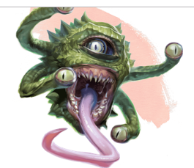**What do you do?**

Suddenly, the torches in the room all ignite and illuminate the room. The round sphere is a sickly green color with hard protrusions alone the back. And 4 short tentacles handing from its side. As you watch, the sphere begins to rise into the middle of the room, and you see the end of the tentacles begin to move and open a large eye on the tip of each. In the center of the sphere, an even larger eye opens along with a giant, toothy mouth. A long, slimy, pink tongue whips out towards you.

DC 12 Arcana to identify.

As you reach the back of the room, you notice a chest.

**What do you do?**

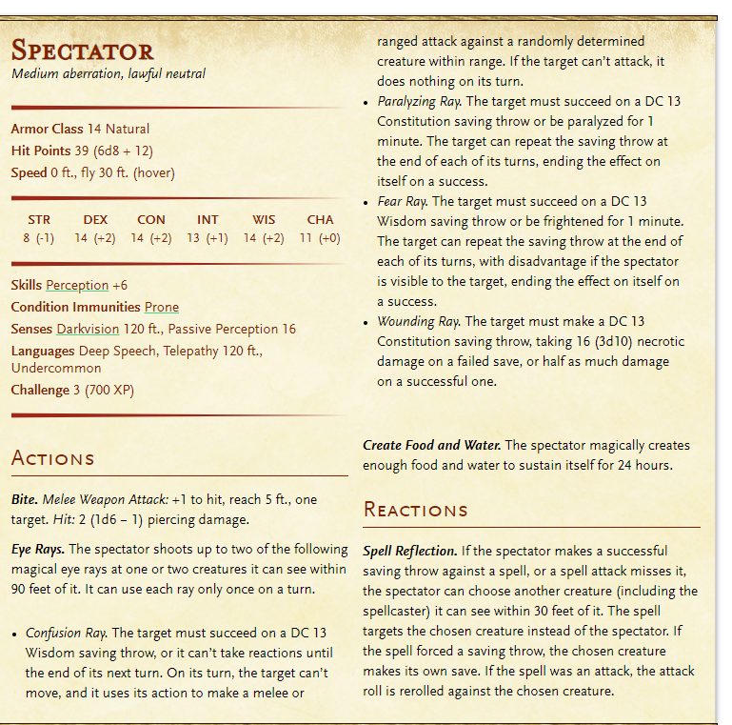

The monster falls to the ground with a shriek. It lies dead on the floor, and the gate behind you opens up.

**What do you do?**

The chest has an assortment of treasure

3 star rose quarts (50gp each), 12 Tiger eyes (10gp each), Small mirror set in painted wooden frame (25gp), gold ring set with bloodstone (250gp), 50gp, 2 potions of lesser healing, 1 potion of greater healing (4d4 + 4), and a golden key.

**What do you do?**

#### Meet the Vampire Celistine

The key opens the lock in the dining room. The giant, beautiful doors swing open effortlessly. The walls are completely clean and built with obsidian walls. The black marble floors are freshly polished and lightly reflect the room around them. The way the light bounces off the marble, it almost appears as if you’re walking on black water reflecting the stars. In the center of the room, the only item in the room, is a golden coffin. You see the girl you fought earlier sitting on it, staring at you. She looks like she has mostly recovered, similarly to you. A quiet click echoes through the impossibly silent room. Jade stands up and move to the side, as the coffin begins to open. A beautiful figure begins to arise, defying gravity, he floats to his feet. It is the man from the painting in above the fireplace.

He steps out from the coffin gracefully. He doesn’t seem to be bothered by your presence as he acknowledges his companion. He takes her chin into his hand and kisses her forehead. It is obvious they have a close bond.

The Man turns to look at you. “I see you have done much better than expected. Jade tells me that you even bested her in combat. I am impressed.” As he speaks, you notice his portrait was missing one major thing – fangs.

**What do you say/do?**

If you attack – The vampire grabs you and throws you across the room. “I have no interest in fighting you,” he remarks.

“Your tiny group seems weak, but you have potential. My master and I will be watching your career very closely. You could be….useful,” his dark smile is unsettling.

“Here. A gift” He gestures at the empty space beside you. A pair of boots (Misty Step Boots – teleportation up to 30 ft, 3 uses per day) appear, a ring (ring of feather falling – no fall damage), and another ring (ring of water walking – can walk on water).

“These should be useful in your journey. We can’t have you dying…unexpectedly.” You’re not sure if he’s trying to save you or plotting your death….

“And one more gift.” He holds his hand out and a small stones levitate from him to you. It is a sending stone. He explains what they do. “Jade, my love” he turns to the green-eyed girl. “I want you to have the other,” he passes it to her, gently. You can tell she is captivated by him. She has not taken her eyes off her master since he awoke. She takes the stone without question.

“There!” he exclaims. “If you have a problem, Jade will help. My love, I think it is time to depart. Congratulations on your victories here today, adventurers. Feel free to wonder the mansion. Once you leave, you will never come back.” He bows deeply “Until we meet again.” And with that, the Vampire, Jade and the coffin all disappear behind a cloud of mist. When the mist clears, they are gone.

#### The Trap Door

Down the trap door, you notice a huge temperature drop. The walls are stone and moist, covered in slime.

To the north, there is a door, and to west there is a door

**What do you do?**

Wine Cellar is clear of monsters. As you inspect the room, you find mostly empty or broken bottles of wine. However you find 6 bottles of red wine that have aged well. Also, You find a Brass mug with jade inlay (250gp).

Through the other door, you see a large pool of water. What this pool could be for is beyond you. A medium sized gelatinous cube jumps around the pool. It doesn’t seem to notice you. At the back of the room, there is another chest.

**What do you do?**

You can avoid the ooze, if you run away from it when it comes around.

book chronicling the lineage of a very minor noble family (25 gp)

1 set(s) of fine clothes (15 gp)

1 gallon(s) of ale (0.2 gp)

10 malachite worth 10 gp each

Bag of Holding

Potion of Healing

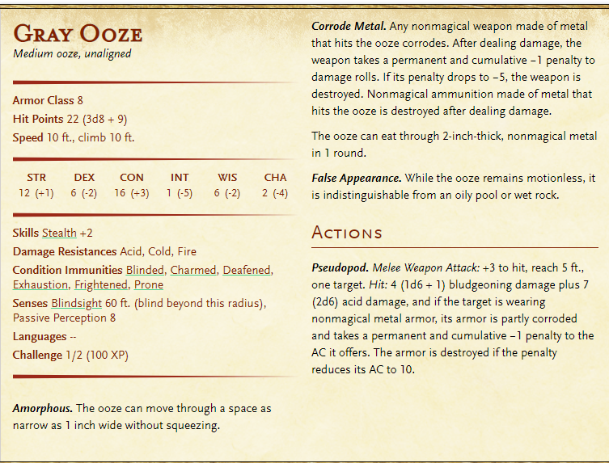

When you exit the mansion, it is completely daylight. The cemetery is no longer there. When you have left the steps, and no one is staring at the mansion, it fades from existence.

**End Campaign 2 _______________________________________________________________________**